CT Scan Protocol Data Capture Form for Effective Dose Estimates

Please ensure that this form is completed as fully and accurately as possible to ensure the most accurate dose estimate.

Hospital | AUTOFILL |  | CT Scanner Details |  | DROP DOWN
Patient Name | CHARFIELD |  |  | Patient D.O.B |  | DATEFIELD
Patient ID # | CHARFIELD |  |  | Patient Sex (M/F) |  | MANDATORY CHARFIELD
Reason for requesting  estimate (include stage of  pregnancy if applicable) |  | TEXTFIELD
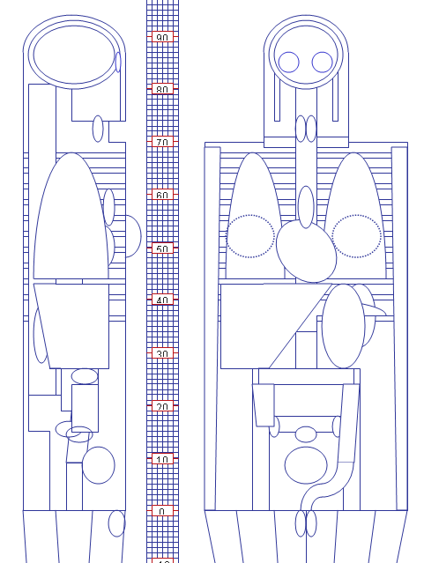
Scan protocol description |  | DROPDOWN (MULTI)
kV |  | FLOAT
mA |  | FLOAT
mA modulation? (Yes/No)  (e.g. SmartmA, AutomA etc) |  | DROP DOWN
Rotation time (secs) |  | FLOAT
Collimation (e.g. 4×3mm,  NOT image thickness) |  | DROP DOWN
Irradiated slice width (mm)  (e.g. 12mm if 4 x 3mm) |  | DROP DOWN
Helical scan? (Yes/No) |  | DROP DOWN
Couch feed per rotation (mm) |  | FLOAT
Couch increment (mm) |  | FLOAT
Pitch |  | FLOAT
Total number of images |  | INT
Image thickness |  | FLOAT
Enter the scanner dose information and the displayed units below (e.g. 20 mSv, mGy, µSv, mGy cm etc).
 | Recorded Dose |  | Units
CTDI_{vol} | FLOAT
Total mAs | FLOAT
DLP | FLOAT
Other relevant details

Mark the start and end points of the examination on the diagram above with clear horizontal lines. If multiple scan protocols are involved please photocopy/copy and use a separate sheet for each examination.

